

High-Level Design

High Level Design

(Swiggy Data Analysis)

Revision number: 1.0

Last date of revision: 22/03/2023

SWIGGY DATA ANALYSIS 1

High-Level Design

Document Version Control

Date Issued

Version

Description

Author

22/03/2023

HLD-V1.0

First Version of Complete HLD

DATTAPRASAD MANDAVKAR

SWIGGY DATA ANALYSIS 2

High-Level Design

Contents

Document Version Control ................................................................................................................ |  |  | 2
Abstract ............................................................................................................................................. |  |  | 4
1. | Introduction ................................................................................................................................... |  | 5
 | 1.1. Purpose of the Document .................................................................................................. |  | 5
 | 1.2. Objective of HLD ................................................................................................................. |  | 5
 | 1.3. Scope of HLD ...................................................................................................................... |  | 5
2. | General Description ....................................................................................................................... |  | 6
 | 2.1 | Product Perspective & Problem Statement .......................................................................... | 6
 | 2.2 | Data Requirements ............................................................................................................... | 6
 | 2.3 | Tools Used .............................................................................................................................. | 7
 | 2.4 | Constraints ............................................................................................................................. | 7
3. | Design Details ................................................................................................................................ |  | 8
 | 3.1 | Process Flow.......................................................................................................................... | 8
 | 3.2 Error Handling / Exception Handling ……………………………………………………………………………….. 8
4. | Conclusion ..................................................................................................................................... |  | 09
5. | References… .................................................................................................................................. |  | 10


SWIGGY DATA ANALYSIS 3

High-Level Design

Abstract

The online food ordering market includes foods prepared by restaurants, prepared by independent people, and groceries being ordered online and then picked up or delivered. The first online food ordering service, World Wide Waiter (now known as Waiter.com), was founded in 1995. Online food ordering is the process of ordering food from a website or other application. The product can be either ready-to-eat food or food that has not been specially prepared for direction consumption.

In the world of rising new technology and innovation, Food industry is advancing with the role of Data Science and Analytics. Data analysis can help them to understand their business in a quiet different manner and helps to improve the quality of the service by identifying the weak areas of the business. This study demonstrates the how different analysis help to make better business decisions and help analyze customer trends and satisfaction, which can lead to new and better products and services. Different analysis performed such as Exploratory Data Analysis and Descriptive Analysis on variety of use cases to get the key insights from this data based on which business decisions will be taken.

SWIGGY DATA ANALYSIS 4

High-Level Design

1. Introduction

This document will be used for documenting High-level designs of project.

1.1 Purpose of the Document

The purpose of this plan is to

- Describe different design approaches.

- Describe different analysis approaches based on variety of Use Cases.

- Describe third party components/tools required for the system.

- Present complete Process Flow followed for this project.

1.2 Objective of HLD

- To provide an overview of the entire system.

- To provide introduction of Problem Perspective & Statement, Data Requirements, Tools used and many more.

- To provide a module-wise breakup of the entire system.

1.3 Scope of HLD

This HLD covers all areas of system.

SWIGGY DATA ANALYSIS 5

High-Level Design

2. General Description

2.1 Product Perspective & Problem Statement

Food industries are having important reflection of the economy from past few decades. Online food ordering is the process of ordering food from a website or other application. The product can be either ready-to-eat food or food that has not been specially prepared for direction consumption.

In this project, we are analyzing the various aspects with different use cases which covers many aspects of Swiggy Food Delivery Service. It helps in not only understanding the meaningful relationships between attributes, but it also allows us to do our own research and come-up with our findings.

The objective of the project is to perform an exploratory data analysis, data pre-processing, & data cleaning and at the end, apply different Data Visualization techniques to get the meaningful insight from the given data. This project aims apply some amazing Python Libraries such as Plotly and WordCloud which will give a boost to our visual understanding of the data.

2.2 Data Requirements

Data Requirement completely depend on our problem.

- In this project, to perform analysis, we are using datasets that are provided by iNeuron Intelligence Pvt. Ltd.

- The features which are taken into consideration are:

- Some of the important features are:

Name | Description
Shop_Name | Name of the Shop/Restaurants
Cuisine | Name of the different Cuisines provided by Restaurants.
Location | Restaurant Area/Location.
Rating | Rating given by the Customers out of 5.
Cost_for_Two (₹) | Approx. Cost of Two people w.r.t. Restaurants.

SWIGGY DATA ANALYSIS 6

High-Level Design

2.3 Tools Used

- Jupyter Notebook is used as IDE.

- Pandas and NumPy are used for Data Manipulation & Pre-processing and Mathematical functions respectively.

- Exploratory data analysis is automated by dataprep.

- For visualization of the plots, Matplotlib, Seaborn, Plotly are used.

- WordCloud is used to representing the Text Data.

- GitHub is used as version control system
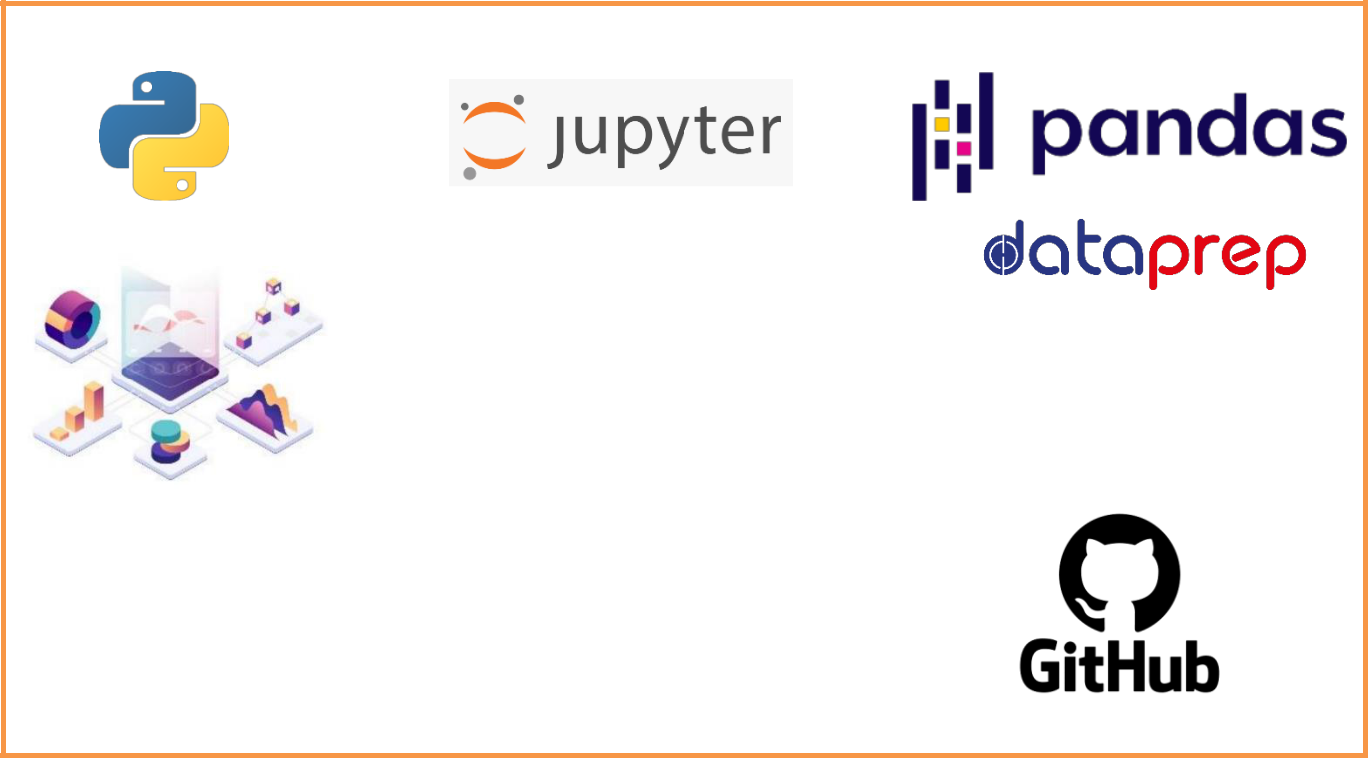

2.4 Constraints

The analysis must be user friendly, code must be neat & clean, EDA must be automated as much as possible because it will save huge amount of time. Moreover, users should not be required to have any of the coding knowledge as the insights they are looking for are mentioned in-detail with respective visuals.

SWIGGY DATA ANALYSIS 7
High-Level Design

3. Design Details

3.1 Process Flow
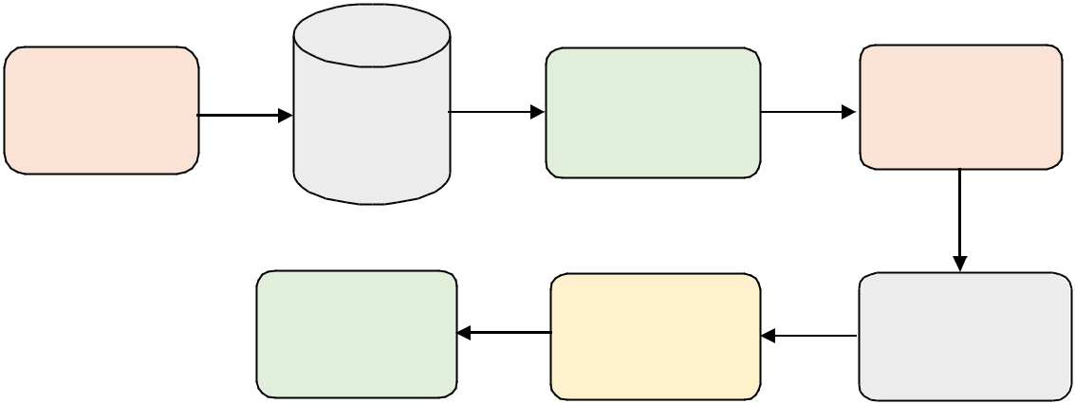

 |  | Perform | Data pre-
Define the Use |  | Perform | Processing, &
Define the Use | Import | Exploratory | Processing, &
Cases | the data | Data Analysis | Data Cleaning

Visualize and | Analyze the | Handling the
share meaningful | Analyze the | Handling the
share meaningful | Analyze the | Categorical &
share meaningful | data | Categorical &
insights | data | Categorical &
insights | data | Numerical Variables

3.2 Error Handling / Exception Handling:

We have designed this project in such a way that, complete script is tested and runs multiple times to make sure that there is no error occurred during process flow.

Additionally, we have also dismissed the un-necessary warnings to avoid confusion by using filterwarnings class from warnings module.

SWIGGY DATA ANALYSIS 8
High-Level Design

4. Conclusion

In this analysis project, we have been analyzed several different use cases for the given dataset to make better business decisions and help analyze customer trends and satisfaction, which can lead to new and better products and services. It has been found that –

- In BTM Area: Most of the Restaurants has 4.0 to 4.2 Rating and Approx. Cost for Two People lies between 200 to 350. (Max. Cost goes up to 600)

- HSR: Most has 4 or above Rating and Approx. Cost for Two People lies between 300 to 400. (Max. Cost goes up to 800)

- Koramangala: Most has 4.0 to 4.3 Rating and Approx. Cost for Two People lies between 200

to 350. (Max. Cost goes up to 600)
With this we can conclude the Most Costly Area is HSR.

We have also analyzed that, we have Total "82" which are the "Budget Restaurants" as well as they
are "Affordable".
On top of that, we have found-out, Most of |  |  | the Affordable/Budgeted Restaurants are
having Excellent | Rating as well. Like, | For Approx. | Cost of "200", "150", "250", and "450",
the Ratings were "4.8", "4.6", and "4.5" respectively.
This might be because Most of the people prefer |  |  | Affordable/Budget-Restaurants which | also
provides good quality of Cuisines.
And On the | other hand, there | are few Expensive Restaurants who doesn't have |  | that
much Rating and they are Expensive too.

Those Restaurants Costs around "600" to "800" for Two People are having the Ratings in between '4.0' to '4.1' which is too less as compared to Affordable/Budgeted Restaurants.

In addition to that, we have also performed Analysis on the Cuisines w.r.t. different

Areas/Location and We have found-out:

- In BTM Area, Most of the Restaurants sell "Chinese" which is around '17.1%' followed by "North Indian" & "South Indian" Cuisines which are around '15.2%' & '9.52%'.

- So, we can also infer that Most of the people are fond of these Cuisines.
• In HSR Area, "North Indian" Cuisines are dominated by around '14.3%' followed

by "Chinese" & "South Indian" Cuisines '9.52%' & '9.52%' Restaurants respectively.

• In Koramangala Area, "Chinese" Cuisines are dominated by around '10.3%' followed

by "North Indian" & "South Indian" Cuisines '9.66%' & '7.59%' Restaurants respectively.

- Furthermore, we have also been analyzed Cheapest/Expensive & Highest Rated Restaurants with Approx. Cost for 2 People and many more.

SWIGGY DATA ANALYSIS 9
High-Level Design

- References

  - Business Model Of Swiggy | How Swiggy works & Make Money | Casestudy (tristatetechnology.com)

  - Swiggy Business Model | How Swiggy Works & Makes Money | Feedough

  - Swiggy - Wikipedia

SWIGGY DATA ANALYSIS 10

